Project development phase sprit - 2

|  |  |
| --- | --- |
| Date | 17 November 2022 |
| Team ID | PNT2022TMID44638 |
| Project Name | Hazardous Area Monitoring For Industrial Plant Powered By IOT |
| Maximum Marks | 20 Marks |

Create a device using IBM IOT platform

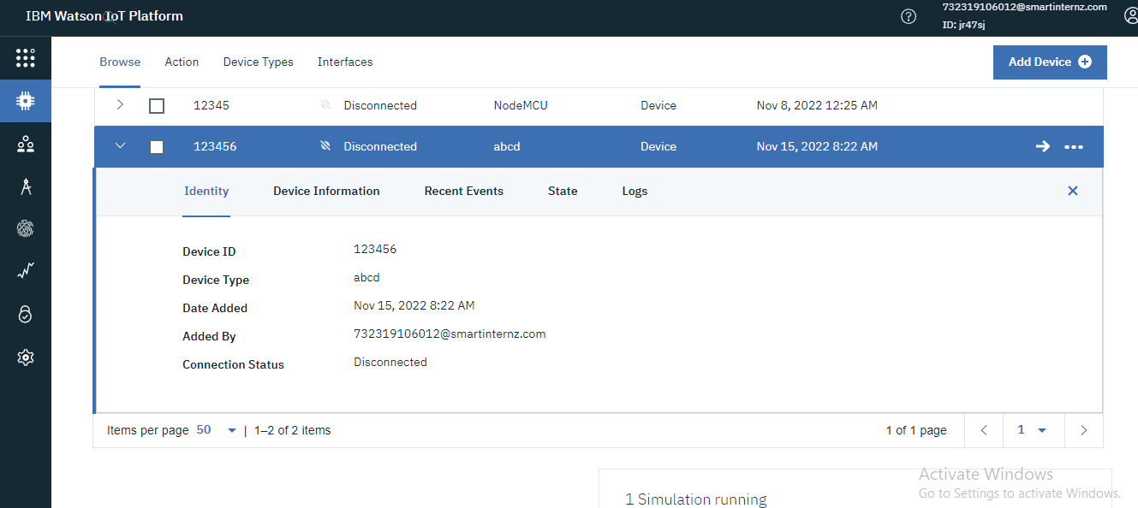

Generating Simulation:

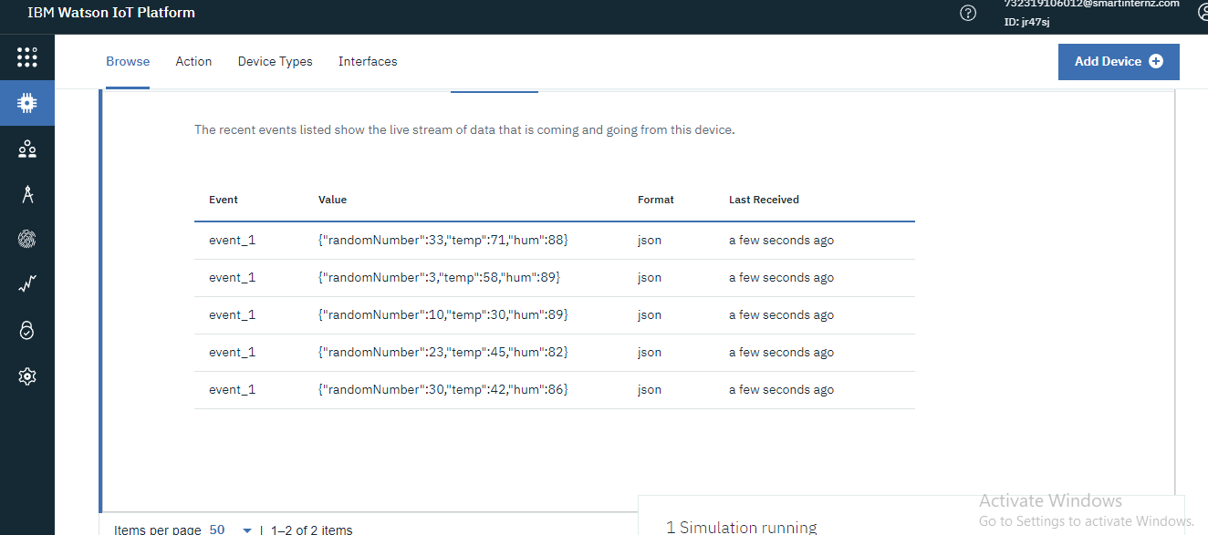

Creating Node-Red:

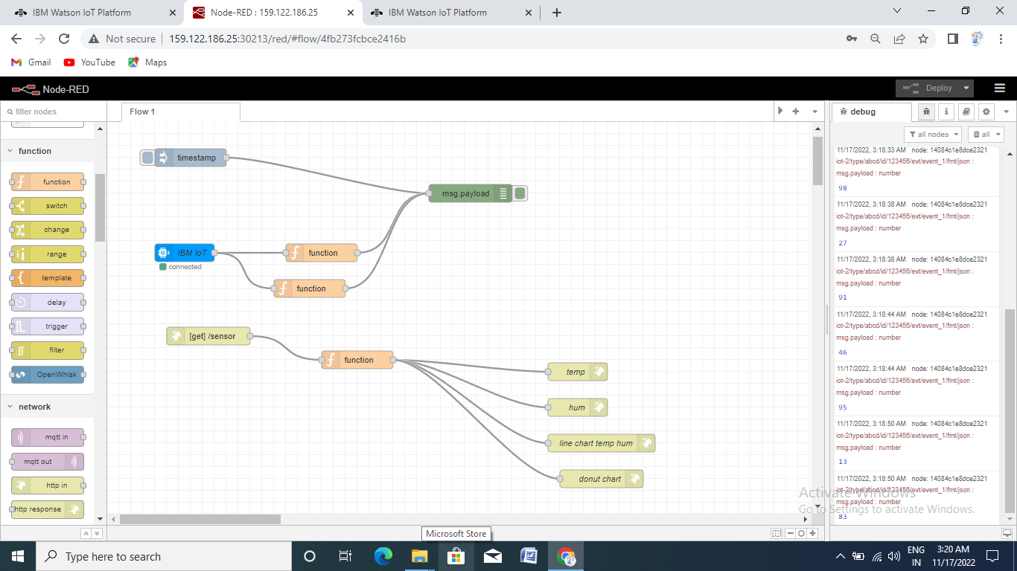

Link using to get the output temp and hum

